

Newington Community Primary School
Princess Margaret Avenue, Ramsgate, Kent. CT12 6HX
Tel: (01843) 593412 Fax: (01843) 850323
Headteacher: Miss Hannah Tudor
headteacher@newington-ramsgate.ken.sch.uk
Ambition, Achievement, Aspiration

Friday 6th March 2026
Dear Parents and Carers
Welcome to the first newsletter of Term 4. Spring has sprung and it is wonderful to see the sunshine and have some dry weather. Term 4 has started with a real busy buzz as we learn all about our core value of “ZEST”. The children have engaged in a range of activities and trips and, of course, World Book Day. Here are some of the highlights of the term so far!
World Book Day 2026
What a wonderful day we had celebrating World Book Day in school. The school came to life with the children’s favourite book characters and the whole school community embraced dressing up and celebrating a love of reading. We all joined together to sing our world famous “Reading Song” that has now had over 1.5 million hits on You Tube! We are very proud of that! A huge thank you to all of our families who supported their children with costumes and to those who came in to school to read with their children. You are all awesome! THANK YOU!
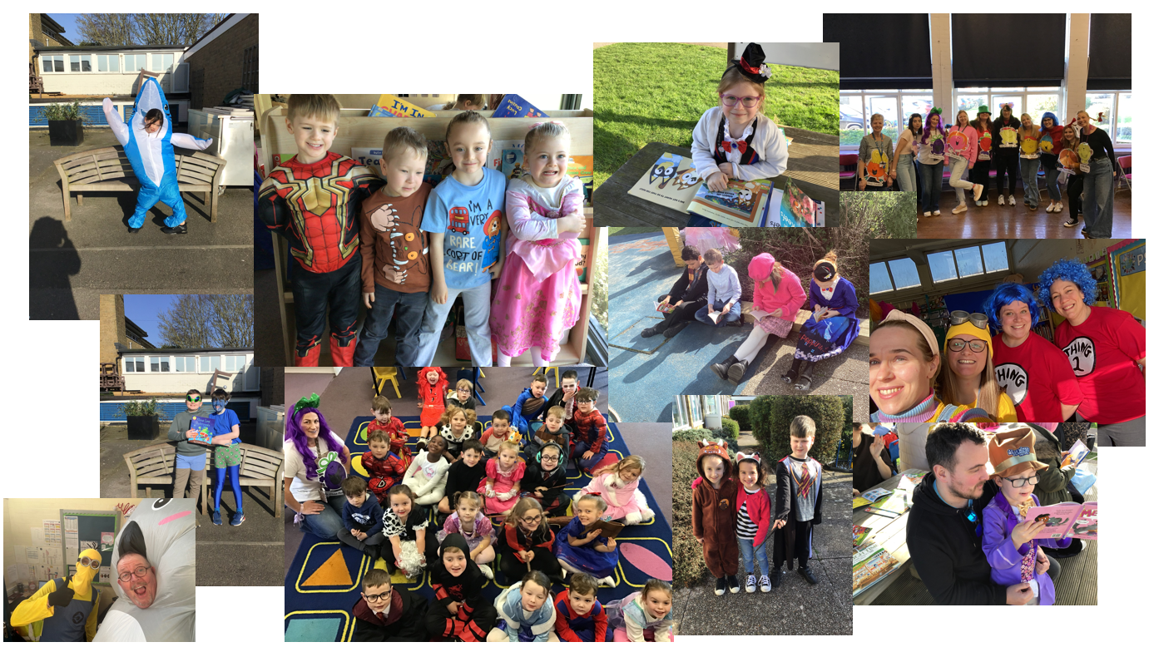

Mr Eldred is currently editing a video scrapbook of this year's World Book Day celebrations which will be released early next week on our YouTube, Facebook and Vimeo channels. This celebration will include a slideshow of the day's events, a unique performance of our 'Reading Song' by our SLT and a couple of stories read by our staff from the books that inspired their choice of WBD costume. We hope that you will enjoy watching it with each other at home and please remember to make every day a reading day.

Year 4 Viking Day
Year 4 started the term with a bang as they all engaged in “Viking Day”. It was wonderful to see the whole year group come together, dressed up, to learn about aspects of Viking life. What a fantastic way for them to start their topic!

Chaucer College Visit
On Tuesday 3rd June, Newington hosted a visit for Chaucer College. Fourteen Japanese students and their teacher, spent the day learning all about life at Newington and how we teach in the UK. They enjoyed a tour of the school, spent time in Maths lessons with Year 3 and Year 6 and then spent the afternoon with Year 5. As a ‘thank you’ to us, they taught our Year 5 children how to greet each other in Japanese, how to write their own name in Japanese and an origami workshop. After the visit, we received some wonderful feedback from the college, noting how polite and engaging our children are and how much they enjoyed their visit. Always great to hear.
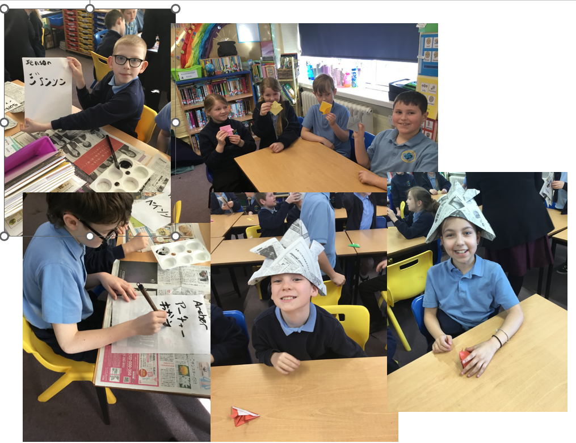
Year 2 – Trip to Monkton
Year 2 enjoyed a wonderful trip to Monkton Nature Reserve this week as part of their Geography learning “Why is our world wonderful?” The children had a great time and came back full of information about all of the facts they had learnt about nature.
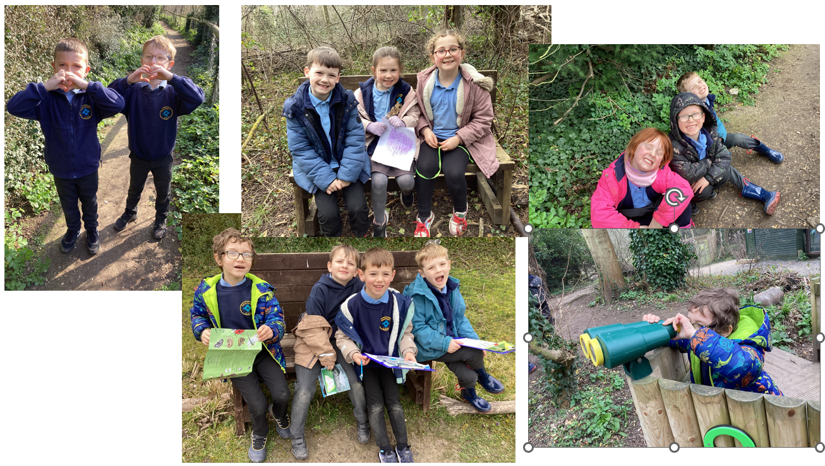
Class Photos – Reminder
Class photos are booked for Monday 16th March 2026. These are lovely memories for the children to have, showing all of the children in their class and their teachers.

Parents Evenings
We enjoyed a really positive parents’ evening event on Wednesday 4th March. It was wonderful to share all of the children’s achievements and progress with our parents. Our second event will run on Wednesday 18th March. If you haven’t managed to book a slot, and would like to speak to your child’s class teacher, please contact the school office to book a place.
Year Groups Location
Nursery, Reception, Year 1 and Year 2 Dining Hall
Years 3, 4, 5, and 6 Main Hall
We look forward to welcoming more parents in to school on the 18th.
Non-Uniform Day
We will be hosting a non-uniform day for two very important causes on Friday 20th March 2026.



Jdksdksdjksdjskjd

To support these two amazing charities we are asking children to wear their own clothes BUT we would also like them to wear the loudest, brightest socks that they can find. We are asking for a donation of £1 per child so that the money can be shared equally between the two charities. Thank you for supporting us.

Term 5 Paddington’s Adventures

Term 5 is approaching fast and we are all very excited about our Paddington show and experience!
The consent forms and payment for this is open until 31st March. Further information about the trips will come out soon.
Attendance
Great news – whole school attendance has really started to improve. The work of our Attendance Champions as well as great support from our families at home means that we have seen real improvements. Attendance is SO important for all of our children. We miss them when they are not here and we know that children who attend school regularly have strong friendships and make better progress. Thank you for supporting your children so brilliantly!
Welcome (Back!)
We welcome Mr Munson to the school staff. Mr Munson is an experienced Key Stage 2 TA who has come to Newington from another local school. He is working in Jupiter class alongside Miss McGarvey and has had a great first week with us all. Welcome Mr Munson.
Welcome back to Miss Berryman. You may see her creeping around the school for the next few Fridays as she starts her return back from maternity leave. We have all really missed her and the children have LOVED having her back in school. Welcome back Miss Berryman!
Earrings
Our school uniform policy states that children should only wear stud earrings to school. Recently, we have seen an increase in the number of children coming to school with earrings that hang below the ear lobe. These are not allowed in school for safety reasons. If your child has an ear piercing, please can you make sure that small studs only are worn to school. Thank you!
Best wishes
Miss Hannah Tudor
Headteacher

