

Newington Community Primary School
Princess Margaret Avenue, Ramsgate, Kent. CT12 6HX
Tel: (01843) 593412 Fax: (01843) 850323
Headteacher: Miss Hannah Tudor
headteacher@newington-ramsgate.ken.sch.uk
Ambition, Achievement, Aspiration

Friday 13th February 2026
Dear Parents and Carers
Here we are – at the end of Term 3. Six weeks full of fun, learning, progress and rain! There has been so much achieved in school in 6 short weeks and this newsletter aims to share some of it with you as well as giving some important updates about school life in Term 4.
Celebrating Our New Thrive Ambassadors

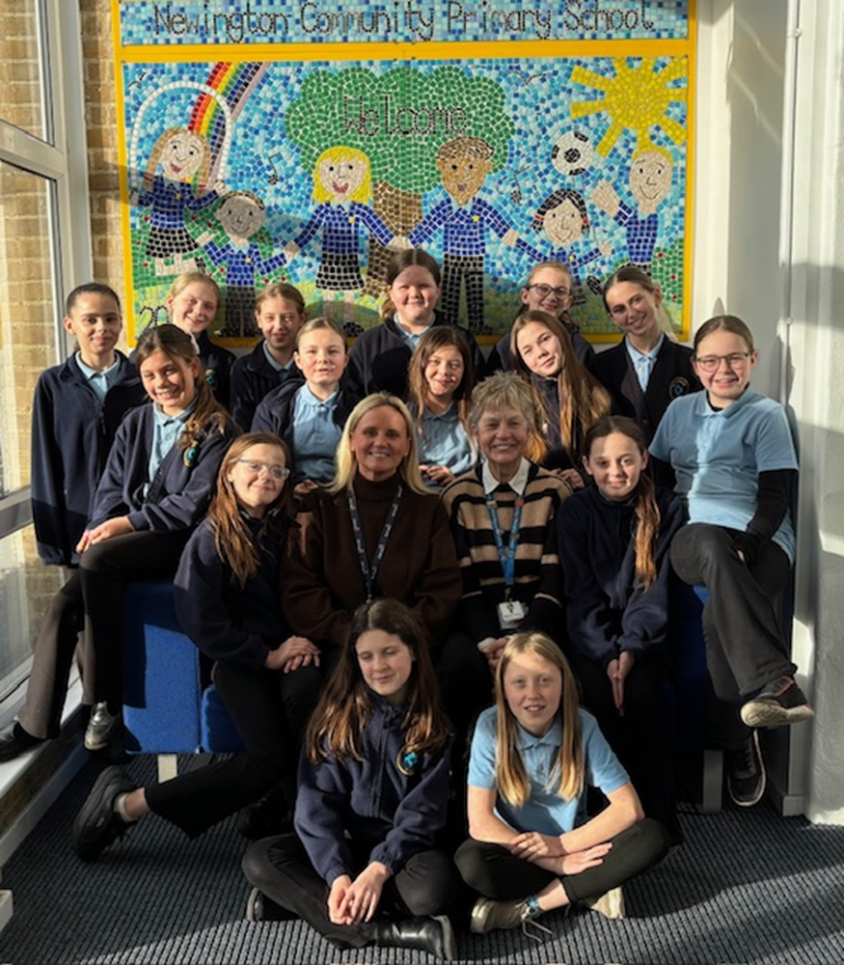

We are delighted to announce the launch of our new Thrive Ambassador roles in school — an exciting initiative designed to support children’s emotional wellbeing and help every child feel safe, valued and ready to learn. The Thrive Ambassadors were introduced during a special assembly led by Mrs Legge, who explained the purpose of the role and the positive impact ambassadors can have across the school. Children learned how Thrive Ambassadors help to support others, model kindness and empathy, and work alongside staff to promote emotional development and resilience.
Following the assembly, children in Key Stage 2 were invited to apply for the role. We were thrilled by the response, with an incredible 88 children submitting thoughtful and enthusiastic applications. This level of interest demonstrated just how passionate our children are about helping others and making a difference within our school community.Selecting the final ambassadors was no easy task. After careful consideration, 15 children were chosen to take on this important responsibility. These children will complete a bespoke 4 week training programme, delivered by specialist teachers, to prepare them for their role. During their training, the Thrive Ambassadors will develop key skills such as listening, understanding emotions, and supporting peers in a calm and nurturing way. Once trained, they will work with identified children across the school under the guidance of staff.
Looking ahead, we are also excited about plans to create a new Thrive Garden within the school grounds. This dedicated space will provide a nurturing and supportive environment where Thrive Ambassadors can work, play and connect with other children. The garden will offer a calm, welcoming area that encourages positive relationships, emotional regulation and wellbeing. We are incredibly proud of all the children who applied and look forward to seeing our Thrive Ambassadors grow in confidence as they take on this meaningful role. This initiative is a wonderful example of our commitment to supporting the whole child and fostering a caring, inclusive school community.
Learning Across the School
Year 1
In Geography this term, Year 1 have been learning all about living by the coast. This has included bringing their learning to life with an exciting field trip to the beach to see how many features they could name. The children now the difference between human and physical features and received lots of lovely comments from members of the public about their behaviour and enthusiasm. Well done Year 1.
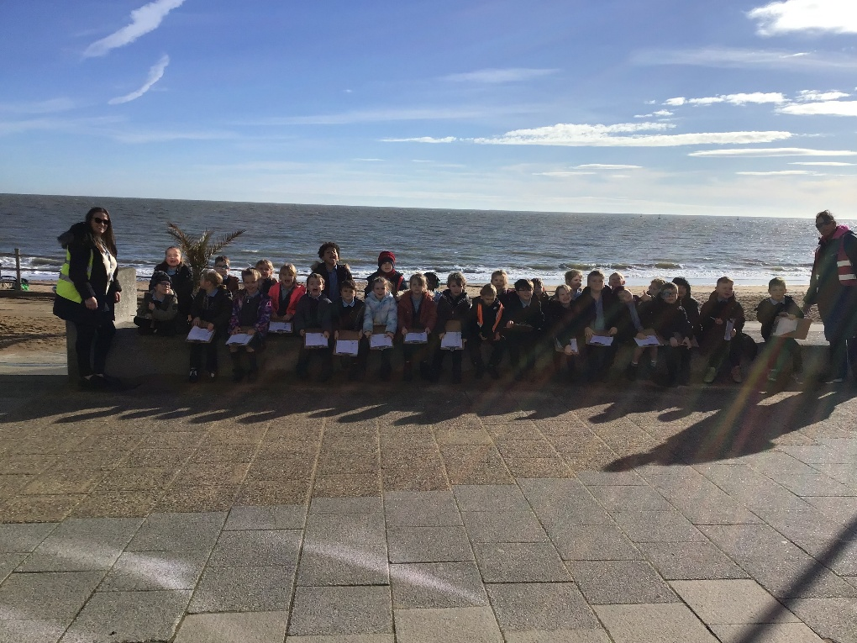
Year 2
Year 2 have been reading The Bog Baby by Jeanne Willis. Each child made their own bog baby and bog baby home to keep it safe. They even read to their bog babies during shared reading. The children taught Miss Tudor all about looking after their bog babies sharing some great information about what they eat and where to find them. Year 2 also understand that we cannot keep bog babies because they need to be released back in to the wild and they told Miss Tudor “We have to let them go no matter how much it hurts us because that is the right thing to do.”
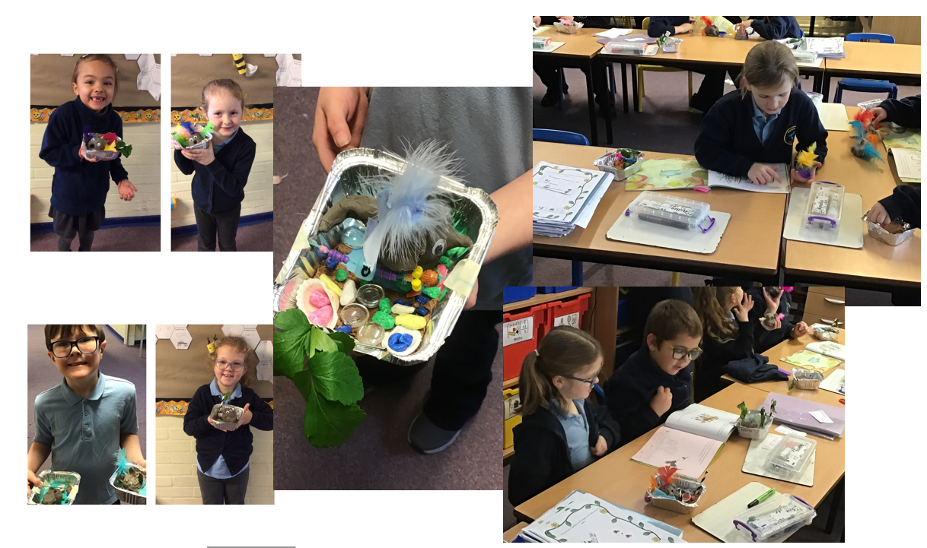
Year 3
We have been learning all about the Stone, Bronze and Iron age. As part of our topic, we designed and created our own Iron Age shields! We have thoroughly enjoyed discussing what era we would prefer to live in. A lot of the children said they would prefer the Stone Age because everybody was equal. Nobody was better than anybody else and nobody was richer than anybody else!
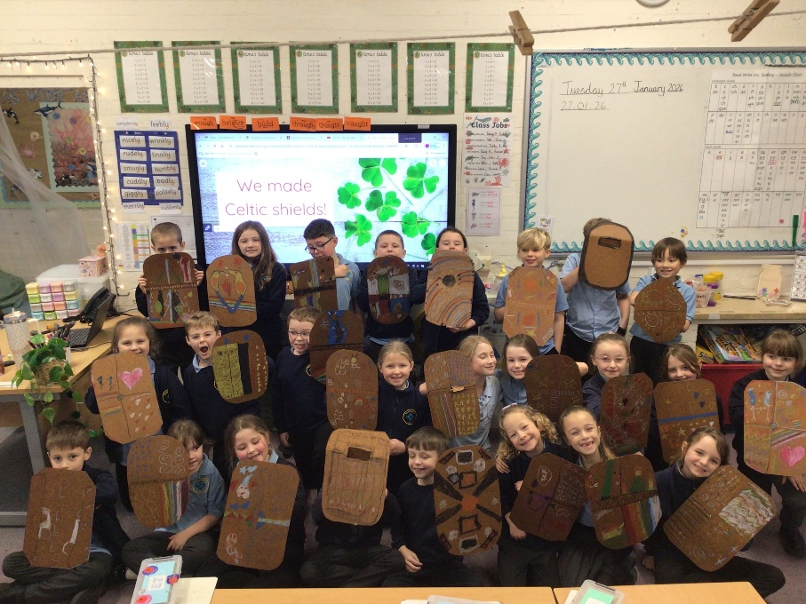
Year 6
Year 6 had a visit from Naomi and Natalie Evans, who are the founders of Everyday Racism - The UK’s largest anti-racism platform. Natalie and Naomi are committed to building a more equitable and inclusive society by tackling racism and discrimination in all forms. The children listened intently and answered questions with maturity and respect. We all took a lot from the assembly, with the most important message being, that it’s not just about being non-racist but we all need to be anti-racist.
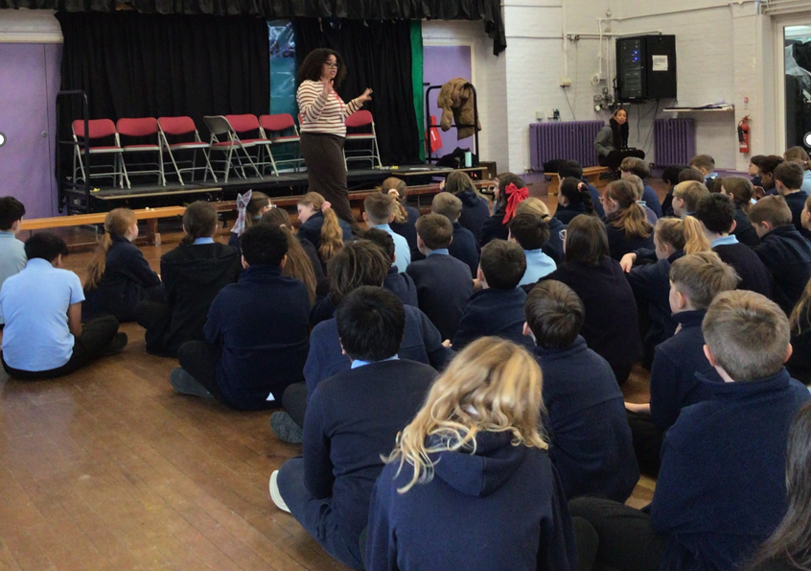
Looking Ahead to Term 4
We will soon be in Term 4, heading towards spring and the warmer weather. Here are some key events happening in Term 4. Diary dates will be sent to parents separately and the calendar on the school website will also show these events too.
Class Photos – Say Cheese!
Class photos are booked for Monday 16th March 2026. These are lovely memories for the children to have, showing all of the children in their class and their teachers.


World Book Day
We LOVE World Book Day at Newington – it is one of the highlights if the school year. This year we will be celebrating on Thursday 5th March and the theme is “Reading for Pleasure”. We have also chosen a school theme of “Making a Difference” and will be sharing a very special book across the school with all of the children. This year’s event is led by Mrs Ditchburn and Mrs Baker and they are asking for everyone to dress up as their favourite book character. Newington always goes the extra mile with the costume creations and we cannot wait to see all of our children at this year’s event.

If this is your first Newington World Book Day, and you would like to see what we got up to last year, head over to You Tube and watch the WBD bonus episode of School News. https://www.youtube.com/watch?v=KGhLO6R33kY
Looking forward to a great day!
Parents Evenings
We are very excited to invite you to our forthcoming Parents’ Evening, which will take place on Wednesday 4th March and Wednesday 18th March 2025. This event presents a valuable opportunity for you to meet with your child’s teacher, celebrate their achievements and discuss any issues or questions with the class teacher. Parents’ Evening is a crucial meeting and it is expected that every child is represented at these meetings, as it will be a chance for a discussion regarding how your child is progressing.
Parents’ Evening will run from 3.35-6.30pm. When booking, please select one date and a time slot that works for you.
Year Groups Location
Nursery, Reception, Year 1 and Year 2 Dining Hall
Years 3, 4, 5, and 6 Main Hall
To book your appointment times, you will need to navigate to the ‘Parents’ Evening Bookings’ tab on our school website. The booking system is open NOW and closes on Friday 27th February 2026. Looking forward to seeing you there!

Non-Uniform Day
We will be hosting a non-uniform day for two very important causes on Friday 20th March 2026.



Jdksdksdjksdjskjd

To support these two amazing charities we are asking children to wear their own clothes BUT we would also like them to wear the loudest, brightest socks that they can find. We are asking for a donation of £1 per child so that the money can be shared equally between the two charities. Thank you for supporting us.

Term 5 Paddington’s Adventures
Term 5 is approaching fast and we are all very excited about our Paddington show and experience!
The consent forms and payment for this is open until 31st March. Further information about the trips will come out next term.

PE Days – Term 4
PE days will be changing next term so that we can ensure swimming provision across the school. The PE days for next term are:
Monday – Year 2
Tuesday – Year 4 and Year 1
Wednesday Reception and Year 6
Thursday – Year 5 and Year 3
Swimming Update from the PE and Sports Team
Year 6 Top Up Swimming - Wednesday 25th February 2026 to Wednesday 1 st April 2026
This year we are trialling something new and offering top up swimming lessons to pupils in Year 6 that have not yet met their National Curriculum requirements. Pupils have been given a letter with all the details of their lesson dates and times. These may not match some pupils in their class so please go by the letter you have received. Due to the nature of these lessons and pool availability pupils will be taken on the Wednesday afternoon based on the data collected from last year.
Year 3 Swimming Dates
Stardust - Thursday 26 th February 2026 – Thursday 2 nd April 2026 – 1.10pm to 1.55pm
Comets – Thursday 26 th February 2026 – Thursday 2 nd April 2026 – 1.20pm to 2.05pm
Term 4 will see the other two Year 3 classes attend swimming. They are booked for 6x45mins lessons across the 6-week term. However, we are aware that they last lesson on Thursday 2nd April will fall outside of school time as the school will close to pupils at 2.15pm. We would still like to take our pupils swimming to complete their course and pupils can be collected from school at the following times.
Stardust – 2.30pm
Comets – 2.45pm
If you have any queries regarding swimming for Term 4, please do not hesitate to contact Miss Bowyer or Mr Moore via email
k.bowyer@newington-ramsgate.kent.sch.uk r.moore@newington-ramsgate.kent.sch.uk
She’s Back!
It may not have escaped your attention that the wonderful Miss Wheatley is back and we are thrilled. Miss Wheatley will be covering in Pegasus Class throughout Term 4. Thank you to all of our families who have taken the time to welcome her back personally.
Staffing Update
It is with sadness that I announce that Mrs Gower, Assistant Headteacher, will be leaving our school at the beginning of Term 5. This has not been an easy decision for Mrs Gower to make as we all know that she loves Newington and working with our youngest children. During her time with us, Mrs Gower has worked hard to adapt our Early Years classrooms in to new, inviting spaces ready for children to start school. She has worked closely with staff and families and got to know the many nursery settings in the area. I know that you will join me in wishing Mrs Gower all the very best for the future and thank her for all she has given to the children and staff at Newington. We look forward to making sure that next term is extra special so that Mrs Gower will take lots of lovely memories of Newington with her.
Thank you for all your support over this term. It has been a hugely positive 6 weeks of learning in school. We all wish you a very happy half term break and look forward to welcoming you back to school for the start of Term 4 on Monday 23rd February at the usual time. Clubs will be running the first week back.

Best wishes

Miss Hannah Tudor
Headteacher

