

Dds
Ambition, Achievement, Aspiration
Newington Community Primary School
Princess Margaret Avenue, Ramsgate, Kent. CT12 6HX
Tel: (01843) 593412 Fax: (01843) 850323
Headteacher: Miss Hannah Tudor
E-mail: headteacher@newington-ramsgate.kent.sch.uk

Monday 2nd February
Dear Parents
Welcome to another newsletter capturing some more of the events and happenings of Term 3. The 378 days of January have finally come to an end and February has started. We have been enjoying a term of hard work, routine and focus with the children responding brilliantly and making some amazing progress.

School Attendance

Good school attendance is so important at Newington - we talk about it a lot! The fabulous news is that attendance across the school is improving and that means that our children are in school more, learning more. FANTASTIC!! Good school attendance supports well being, friendships and develops a strong work ethic that will support our children throughout their education and into adult life. It really is so important.
We will be celebrating all children across the school who have 95% attendance or better at the end of this term. There are a lot of children which is great and we think that they deserve to be recognised and celebrated. If your child has 95% attendance or better, they will be bringing home a card like this

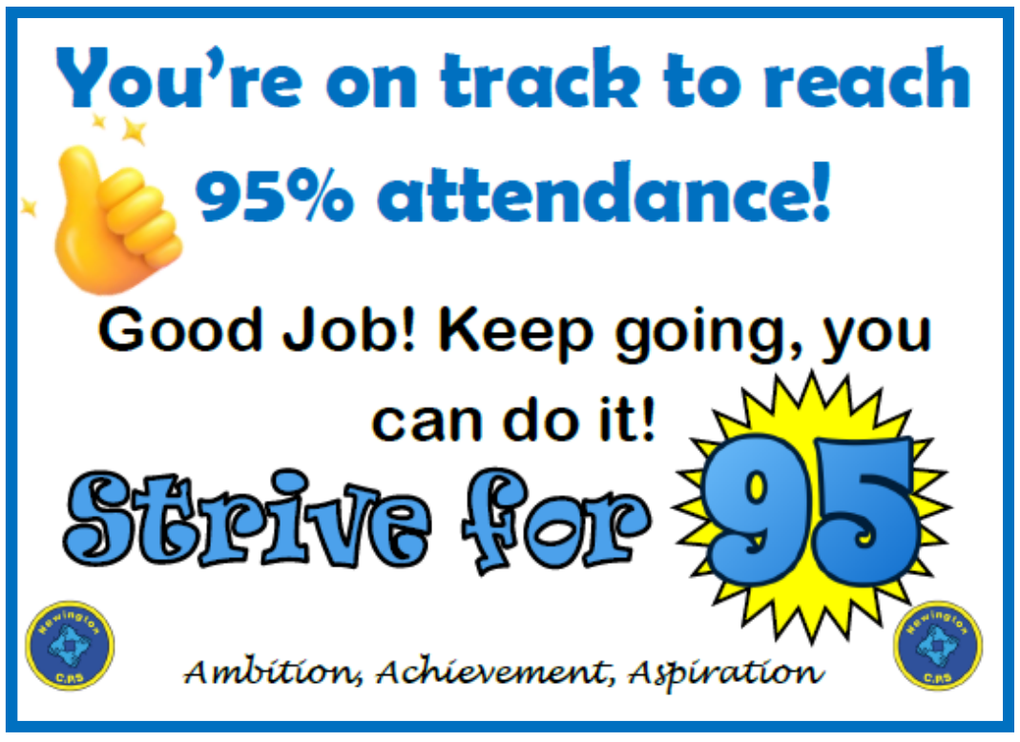

This card will enable them to access their chosen treat during the last week of term. We are looking forward to celebrating with all of the children who come to school regularly or those who have worked really hard to improve their attendance and get it to 95% or above.

What can you do help?

As a parent or carer, you have an important role in making school attendance a priority. Only keep your child off school when they are genuinely too ill to attend. Book medical appointments and holidays outside of school time and talk to us if you're having difficulties with attendance. We are here to support you with attendance. For more information check out The Education Hub website

https://educationhub.blog.gov.uk/2025/08/why-school-attendance-matters-and-what-were-doing-to-improve-it/

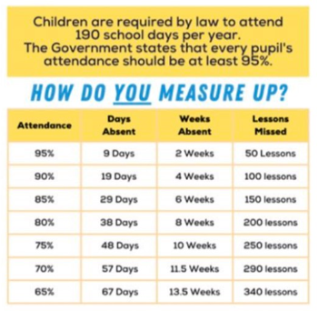

NSPCC Number Day
We are delighted to be supporting the NSPCC by taking part in Number Day on Friday 6th February 2026.

We are having a fun day of maths activities, and we will be taking part in Dress up for Digits. Pupils are asked to wear an item of clothing with a number on it (football shirt, cap, netball shirt or even a onesie!). Or get even more creative by dressing in a maths or numbers theme. To help raise money for the NSPCC, we are asking for donations. Please send in any spare change you may have, no matter how small, as a donation.

Another great Newington music number!
Mr Eldred and Mrs Groom have been hard at work writing the latest song to add to the Newington repertoire. “House Heroes” celebrates the famous people who have inspired the names of our 4 houses. Amelia Earhart, David Attenborough, Rosa Parks and Neil Armstong. The children have been working hard over the last 2 weeks to learn the new school and sing it together as part of our weekly singing assembly. It sounds great and we cannot wait to share it with you all soon!
JLT in Action
Our Junior Leadership Team (led by Mrs Morris) are such a vehicle for change in our school. They work closely with school staff to bring about some key changes that our children have asked for. JLT organised all of the school discos in Term 2, often staying behind to support the running of the stalls and events. They then enjoyed a JLT meeting where they counted all of the wonderful money that the discos had raised - £634 in total!! JLT then decided how they could spend the money to have an impact on school life for ALL of the children and they decided that new wet play games were needed for classrooms.


Parking
Here is another desperate plea for parents and carers to consider how they are parking when picking up and dropping off. No vehicle should be parked on the zig zag lines or on the double yellow lines. Cars should not be on the path or the grassed areas and no car should be parked across someone’s driveway. Despite regular reminders, we still receive a large number of complaints concerning parking. The council will be monitoring the situation closely in the coming weeks.

Free School Meal Food Vouchers - Half Term Holiday
We have received the list of families who are eligible for free school meal supermarket vouchers over the half term break. These vouchers will be ordered and distributed next week. Please ensure that your voucher works before the school closes for the holiday on Friday 13th February. There will be nobody available during half term to help families with any issues.
Term Dates
A reminder that the end of Term 3 will be on Friday 13th February. School will finish at the usual time of 3.20pm. Term 4 will begin on Monday 23rd February. Gates will open at 8.25am and at 7.45am for Breakfast Club.
This is not the final newsletter of the term. Our final celebration of Term 3 at Newington will come out to you on Friday 13th February and will aim to capture all of the learning that has taken place this term as well as a few reminders for Term 4 and some great ideas for activities in the half term holidays.

We all wish you a great week!
Miss Hannah Tudor

