
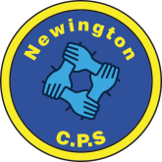
Dds
Newington Community Primary School
Princess Margaret Avenue, Ramsgate, Kent. CT12 6HX
Tel: (01843) 593412 Fax: (01843) 850323
Headteacher: Miss Hannah Tudor
E-mail: headteacher@newington-ramsgate.kent.sch.uk
Ambition, Achievement, Aspiration

Friday 16th January 2026
Dear Parents

Welcome back to school to all of our families and a very Happy New Year! We all hope that you all enjoyed a wonderful holiday and are ready to see what 2026 has in store for us all. The children have settled back in to school life brilliantly and it has been a joy to hear all their exciting news from the Christmas holidays. In this newsletter we celebrate our New Year’s resolutions and provide some valuable information for the term ahead.

Hook Days – Term 3 Learning

The whole school enjoyed a “Hook Day” on the first day back. The purpose of this day is to “hook” children back in to learning and excite them for the term’s learning. We had some brilliant activities being carried out across the school.
Year Two took part in a Tremendous Travellers Hook day that linked to their History topic this term. They dressed up as adventurers and explorers to think about what travellers and explorers would need to take on a journey to stay safe and survive. As part of the day, each child made their own pair of binoculars and a treasure map. We all had a brilliant day!

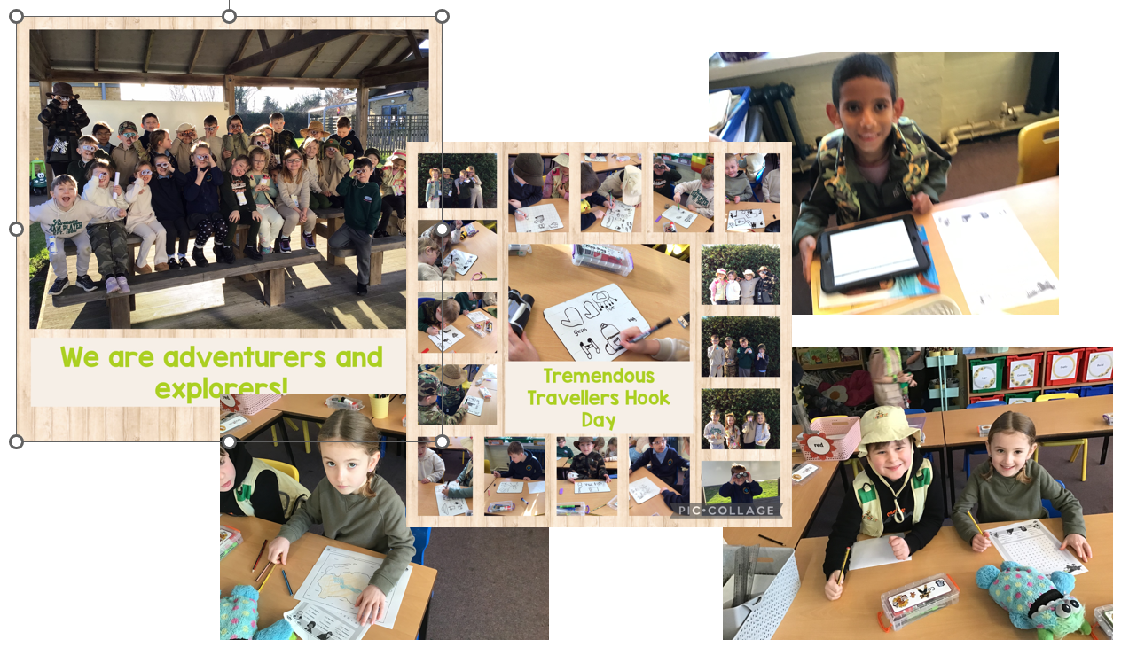
GRIT

Our core value this term is GRIT and we have been introducing this to the children through our Assemblies this term. We are teaching them that it is important to never give up, even when learning may get tough. We are helping them to see that learning can be challenging but they need to be confident that this is all part of learning something new. We have been sharing lots of stories of inspiring people who have succeeded despite great setbacks.
Someone who achieved against the odds and stood up for her beliefs was Rosa Parks. She famously said “Never be fearful about what you are doing when it is right.” We will be learning more about Rosa Parks on February 4th as we mark Rosa Parks Day in school. We are so inspired by her, we named one of our school houses after her!

Reading at Home

Reading is one of the most important skills that we can give to our children. Research shows that reading ability will affect their life chances and mental health. We want to open them up to a whole work of imagination and learning through books. We aim for children to read (or share a book) five times a week and we ask that adults at home support us by signing their child’s reading diary. There are lots of rewards in school for home reading and the children’s commitment is always recognised and celebrated in class. Please can we ask all parents to encourage home reading and to read with their child five times a week so that we can continue to ensure that all of our children are able to read well.

Chinese New Year
We will be celebrating Chinese New Year during the final week of this term. The first day of Chinese New Year begins on the new moon that appears on the 17th February this year. 2026 is the year of the Horse, the 7th animal in the 12-year cycle of the Chinese zodiac. The horse is a great symbol to support learning in school. It brings a dynamic energy and is connected to a year of ambition – something we strive for for every child at Newington. We look forward to sharing our learning with you.


Speech and Language Workshop
We will be hosting a Speech and Language Parent Workshop on Wednesday 21st January at 9.15 in the dining hall. If you are a parent or carer of a child in Nursery or Reception and have any concerns about your child's speech and language. We will be joined by our specialist SALT team, who will be there to give advice and support. Come and along and find out how we support children in school and get some tips on how you can support your child at home. No need to book. If you would like some more information, please email Mrs Legge on s.legge@newington-ramsgate.kent.sch.uk. Look forward to seeing you.
NSPCC Number Day
We are delighted to be supporting the NSPCC by taking part in Number Day on Friday 6th February 2026.
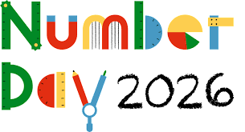
We are having a fun day of maths activities, and we will be taking part in Dress up for Digits. Pupils are asked to wear an item of clothing with a number on it (football shirt, cap, netball shirt or even a onesie!). Or get even more creative by dressing in a maths or numbers theme. To help raise money for the NSPCC, we are asking for donations. Please send in any spare change you may have, no matter how small, as a donation.
Newington Babies
We send all our love and best wishes to two members of staff who are awaiting the arrival of their babies. Miss Musselwhite (Year R) left last Friday to have her baby and Miss Halliday (Year 6 – Luna Class) will be leaving us this coming Friday. We wish them both all the very best for the safe arrival of their babies. I am sure that they will be sharing pictures with us all when the time comes.

School News
Mr Eldred and Mrs Groom are working on the next episode of School News! This exciting broadcast will share with you all key dates and news from across the school and will support all of the information given in this newsletter as well. School News is a great way of building our children’s confidence and ensuring that we communicate with our community about all the great things taking place in school.

We all wish you a great week!
Miss Hannah Tudor

