

Dds
Newington Community Primary School
Princess Margaret Avenue, Ramsgate, Kent. CT12 6HX
Tel: (01843) 593412 Fax: (01843) 850323
Headteacher: Miss Hannah Tudor
E-mail: headteacher@newington-ramsgate.kent.sch.uk
Ambition, Achievement, Aspiration

Friday 17th October 2025

Dear Parents and Carers
What a fabulous Term 1 we have had in school, packed with lots of great learning and starting the year as we mean to go on. It has been a busy, long term and I am sure that many of you are finding that your children are starting to get a little tired. An enormous well done to our new starters in Nursery and Reception who have settled brilliantly in to school life and really have achieved so much during this first term at school. We thank all parents of children in these year groups for working so well with us to ensure that we give every child the best possible start.
Term Dates
As today is the last day of Term 1, we want to remind all parents that Term 2 will begin for all children on Monday 27th October 2025. Gates will open at 8.25am and Breakfast Club will run from 7.45am. In Term 2, Friday 14th November will be an INSET day and the school will be closed to children.
Entrance to Secondary School – Year 6 Parents
A reminder to all parents of Year 6 children that the deadline for the Secondary Common Application Form is Friday 31st October 2025.
Bringing Democracy to Newington

Our new Head Pupils are Lily-Rose and Ollie. They will be well support by our Deputy Head Pupils, Pixie and Freya . We are incredibly proud of all of the children who were part of the campaign and all children across the school for voting. I am very much looking forward to working with the team this year.
Our new House Captains have also been elected for this year. They are:
Neil Armstrong: Indy and Theo
Sir David Attenborough: Rogan and Kali
Rosa Parks: Vivienne and Riley
Amelia Earhart: Jude and Sophia
Maths Open Afternoons
It was wonderful to see so many parents for our Maths Open events last week. We will be hosting similar events throughout the year to give parents more of an insight in to our curriculum and how it is taught. Thank you to parents who gave up their time to come along and learn Maths with us.

NCPS Fundraising
It has been an exceptional term of fundraising for our school. The children were so active in getting sponsorship for our Olympic event, raising a total of £9397.22 for our school! Amazing! This money will be spent on sports equipment to enhance our PE curriculum and ensure that our children have the best possible equipment to help them to keep active.
We also raised £591.44 for Young Minds as part of our Hello Yellow day on the 10th October. What a fantastic team effort from our whole community. Thank you for your generosity.
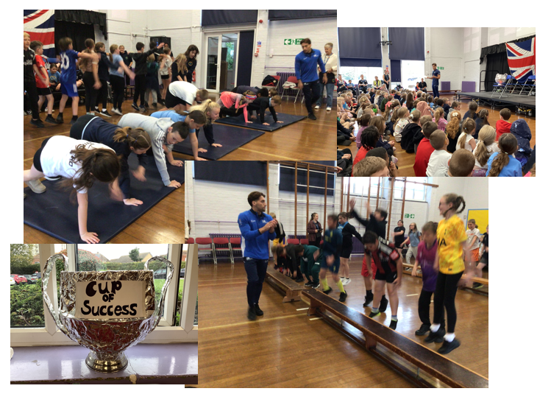

Author Visit to NCPS
On Friday 10th October, coinciding with Hello Yellow World Mental Health Day, years 5 & 6 had the privilege of having award-winning author Lucy Strange and illustrator Pam Smy visit. Together, they have written two books in a ghostly mystery series and they came in to school to tell us all about them. We were given an inside look into how Lucy plans her stories, and even had a go at planning our own! Pam then shared her sketchbooks with us and we discussed how artistic errors can lead to exciting results. This ended with us being able to ask them both any questions that came to mind. A wonderful morning was had by all, full of creative inspiration. We feel so lucky that they came to visit us and signed some books!
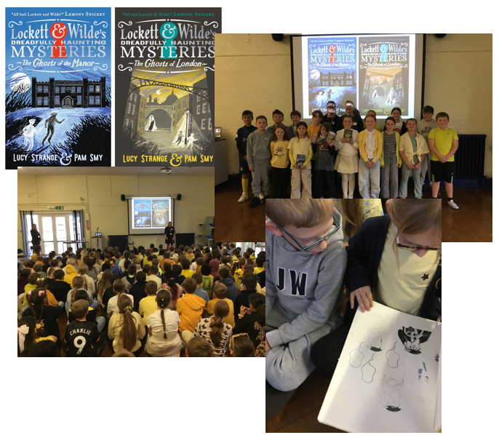
Half Term – Food Vouchers
Half term food vouchers will be available to all children who are eligible for free school meals. Kent County Council will provide a £10 for each eligible child. There have been some issues with the ordering system this term but vouchers should be with families for the start of the holidays.

Looking ahead to Term 2
We are always looking for ways to develop our children’s awareness of the world around them and the responsibility that they have to making the world a better place. Here are some key dates for Term 2 that we would love ALL children to be involved in:
Diary Dates for Term 2
Monday 10th – Thursday 13th November | Anti-Bullying Week | Talk to us at home about the difference between an argument with a friend and being bullied.
Monday 10th November   | Odd Socks Day | Nursery to Year 6  Wear odd socks to school
Thursday 13th November | World Kindness Day | Ask us at home “How did you show kindness today?”
Thursday 13th November   | Children in Need | Nursery to Year 6  Wear pyjamas or something spotty to school and bring in a donation to this amazing charity. (Children to hand coins to their class teachers)

Newington Sport
Super Saturday:
We would like to congratulate each and every child who attended our Year 5/6 Super Saturday Football event, hosted by Baypoint Sports Club.
The first round for fixtures were a huge success, with our team only conceding 1 goal and finishing top of the group table. The recent introduction of GK Kian and Eben making a huge difference to our squad, providing a solid performance each and every time he set foot on the pitch. Defensive players Charlie and Freddie provided stability throughout the group stages, making it almost impossible for opposing teams to have any success. Our newest introduction of Year 5 players Ellis and Max, both showed great attaching and defensive displays settling into the team very well. Jackson and Theo were very much our play makers, creating opportunities in the final third, and getting on the score sheet themselves. Arli caused endless number of problems in with his dribbling with the ball and physicality.
After the success in the group stages, we reach tier 2 on goal difference and entered a very strong final set of group games. Finding a limited success in our first game, our team never gave up and showed perseverance throughout which I couldn’t be prouder of.
We finished 3 in the group stages- Well Done everyone.
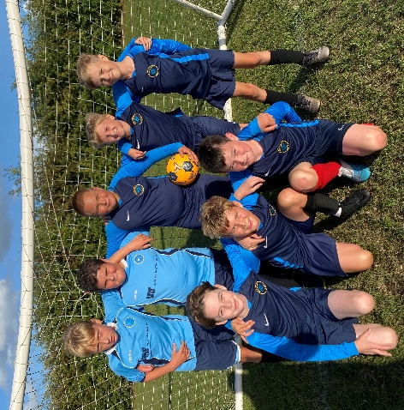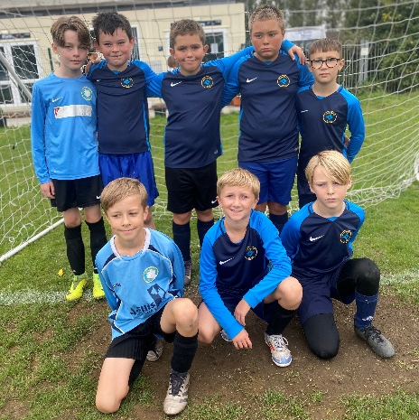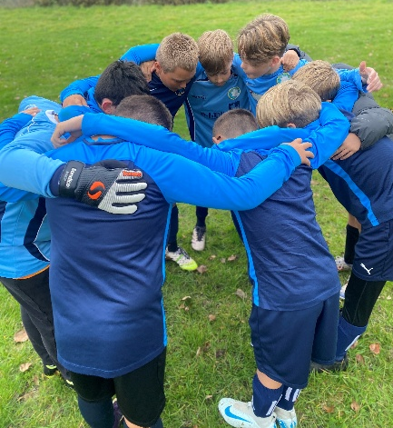
Friday Festivals
Term 1 saw a number of Year 5/6 Festivals hosted at NCPS, these events are organised by Thanet Passport and have become a set of events we regularly host in Term 1.
Our Teams across all Festivals has been very competitive, only losing two games across 3 hosted events. We’ve had the pleasure of introducing both players who already compete at club level, to those who have never played in a team structure.
A special mention to Rogan who across all festivals always led by example, whether is his physicality and ability to finish, or his defensive displays when the play has broken down. In addition, I’d like to say huge well done to Jake, who has settled well into the year 5/6 with his endless amount of pace and desire to want the ball.
Finally, I would like to say Huge Thanks you to parents and guardians for your support, cheering from the sidelines across all events.
Girls Football Festival
Firstly, what an outstanding event of Year 5/6 Girls Football Last Thursday was. Our Year 5/6 girls put on a very competitive display of football against other local primary schools, such a Bromstone, St Josephs, St Laurence and Holy Trinity.
I would like to highlight that this event was the first time many players have played in a team structure The work rate, desire to win the ball and sheer enjoyment I could see from each and every player make the whole event even more worthwhile. Shout out to our amazing squad, Ella, Olivia, Summer-Lily, Vivienne, Pixie, Lola, Ellissa, Sophia and Freya
Although this event had was didn’t highlight a clear winner, our team played some great football and positive passing. A special mention to Freya, Ella, Olivia and Ellissa who provided a great deal of structure to the team and played a lead role in the team’s success. Furthermore, Well Done Lola, Vivienne, Summer-Lily, Pixie and Sophia who some rotated in goal, was on the front line of tackling too. Again, thank you to all the parents and guardians in attendance, we are very excited to see the girls back in action again soon.
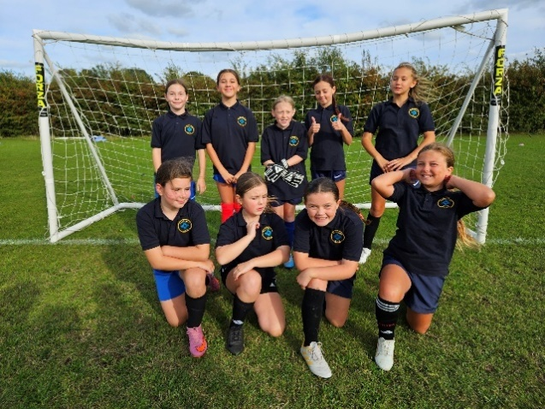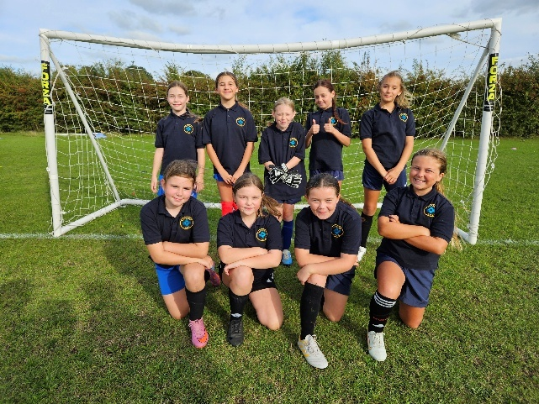
RM STAR PLAYERS OF THE TERM
AFTER SCHOOL CLUBS IN PARTNERSHIP WITH NCPS

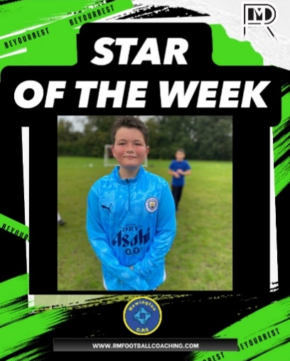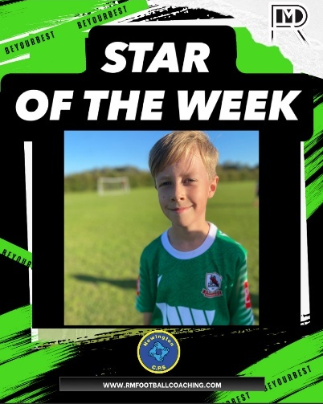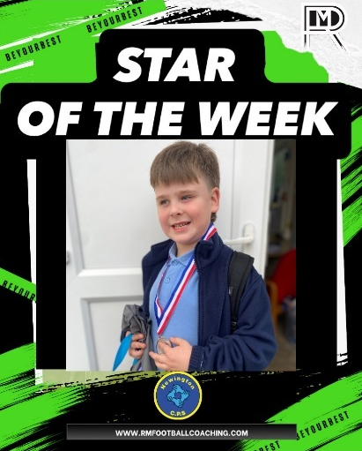
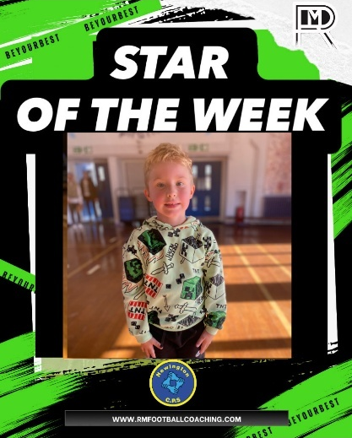

TERM 2 BOOKINGS:

BOOK HERE: https://www.rmfootballcoaching.com/book-online

For Further information please visit:
https://www.rmfootballcoaching.com/about-1
OCTOBER HALF TERM FOOTBALL CAMPS

BOOK HERE: https://www.rmfootballcoaching.com/book-online
FOR FURTHER INFORMATION PLEASE VISIT:
https://www.rmfootballcoaching.com/copy-of-development-centre-1

PE Days
Here are the PE days for Term 2.

Monday: Year 6 (am) and Year2 (pm)
Tuesday: Year 3 (AM) and Year 1 (PM)
Wednesday: Reception (AM) and Year 5 (PM)
Thursday: Year 4 (PM)

Please ensure pupils with long hair have it tied back for their PE days and no jewellery.
As the weather is now changing, it will become increasingly colder throughout term 2. Please ensure your child has trainers for PE due to better grip, a coat especially for PE days and hat/gloves are allowed too. Most PE lessons will take place outside where possible and it is important that your child is dressed appropriately for the weather.

Lunches
The updated menu is available on see-saw for all of our families. The autumn and winter pudding menu is now is place. There are no changes to main meals. We will start the new term on Week 1 of the menu.

Road Safety with Paul
We are very lucky to have such a fab crossing patrol person. Paul is always happy and cheerful and is outside in all weathers, making sure our children cross the road safely. He is a Newington treasure! Paul has asked for your help so that he can continue to do an amazing job, keeping everyone safe. Please can all adults ensure that their children remain close to them at all times and are given reminders to wait for Paul before crossing the road. We have had incidences of small children running ahead of parents and not being able to cross the road safely. Also, please can all children who come to school by bikes or scooters, be reminded to get off of these and WALK across the road when they cross with Paul. Children shouldn’t be riding scooters or bikes when crossing with Paul. THANK YOU!

Road Closure
We have been notified by Thanet District Council of a road closure that will be in place after half term. Princess Margaret Avenue will be closed between the junctions to Auckland Avenue and Melbourne Ave from 20th to 31st October. We anticipate this causing some considerable disruption for the first week of term and would encourage as many families as possible to walk to school whilst this road closure is in place. We will keep families up to date as soon as we hear any more from Thanet District Council.

Thank you for all your support with our Term 1 adventures. We have loved every minute. It is time for our wonderful staff to rest over half term and enjoy time with their own families and children. Please be mindful that staff will not respond to emails or see-saw messages next week but will be back, ready to go for the start of Term 2 on Monday 27th October. We look forward to seeing you all then.
Have a great week from all of Team Newington! See you next term!

With very best wishes

Hannah Tudor
Headteacher

