

Dds
Newington Community Primary School
Princess Margaret Avenue, Ramsgate, Kent. CT12 6HX
Tel: (01843) 593412 Fax: (01843) 850323
Headteacher: Miss Hannah Tudor
E-mail: headteacher@newington-ramsgate.kent.sch.uk
Ambition, Achievement, Aspiration

Friday 12th September 2025

Dear Parents and Carers
What a brilliant start to the year we have had! It has been great to welcome all of the children in to the school for the start of the new school year. The children have settled so quickly, it’s like we were never away! This newsletter contains some important information for parents as well as a peek in to some of the brilliant learning taking place across the school so far this term!
Who should I speak to about…….?
We are a large school and it is important that parents and carers know who to speak to with any concerns or queries they may have. Here is a list of staff you can contact if you need to.
Your child’s progress in class, home learning, friendships, classroom incidents | Contact your child’s class teacher via see-saw or arrange an appointment to speak in person
You are concerned a child has been harmed (safeguarding) | Miss Harrison  Tracey Stillman | r.harrison@newington-ramsgate.kent.sch.uk  t.stillman@newington-ramsgate.kent.sch.uk
Your child cannot attend school | Sarah Ayling | attendance@newington-ramsgate.kent.sch.uk
Your child has an illness or injury that will require treatment in school | Sharon Robb | s.robb@newington-ramsgate.kent.sch.uk
Wraparound provision | Tracey Stillman | t.stillman@newington-ramsgate.kent.sch.uk
Uniform | Speak to staff in the office
On-going behaviour concerns that have not been resolved after talking to the teacher | Miss Harrison  Miss Tudor | r.harrison@newington-ramsgate.kent.sch.uk  headteacher@newington-ramsgate.kent.sch.uk
After School Clubs | Mrs Clements | g.clements@newington-ramsgate.kent.sch.uk
Special Educational Needs and referrals to outside agencies (Greenbanks etc) | Mrs Legge | s.legge@newington-ramsgate.kent.sch.uk
Your child has developed an allergy | Miss Robb | s.robb@newington-ramsgate.kent.sch.uk
Holiday food vouchers and HAF Club | Tracey Stillman | t.stillman@newington-ramsgate.kent.sch.uk
Your child is playing in a school sports event | Mr Moore | r.moore@newington-ramsgate.kent.sch.uk
Admissions to school or nursery/Open events for new parents | Mrs Biggs | c.biggs@newington-ramsgate.kent.sch.uk

Term Dates
We ask all parents to note that Friday 14th November is an INSET day and the school is closed to children.
Shout out to the Newington Unsung Heroes
A huge shout out to our site team, led by Mr Joy and our cleaners for all of their hard work over the summer. Once again, a huge amount of work has been put in over the summer holidays. We have moved year groups, established brand new classrooms for our Reception children, had new corridor flooring, replaced the stage in the KS 1 playground, a new Nursery floor, Year 3 classrooms have been redecorated and new fencing has been installed at the main school entrance. Every child in the school also has a brand-new desk and chair!
We cannot thank our wonderful site team enough. They completed 500 working hours over the summer holidays. Moved 20 tonnes of furniture and filled three skips. The school looks amazing and it has been wonderful to see the children’s faces when they have seen their new classrooms. All of this work has also meant that our teachers and TAs had to put in quite a few hours of additional work over the summer to make sure that classrooms were ready, inviting and purposeful for every child. Well done Team Newington.
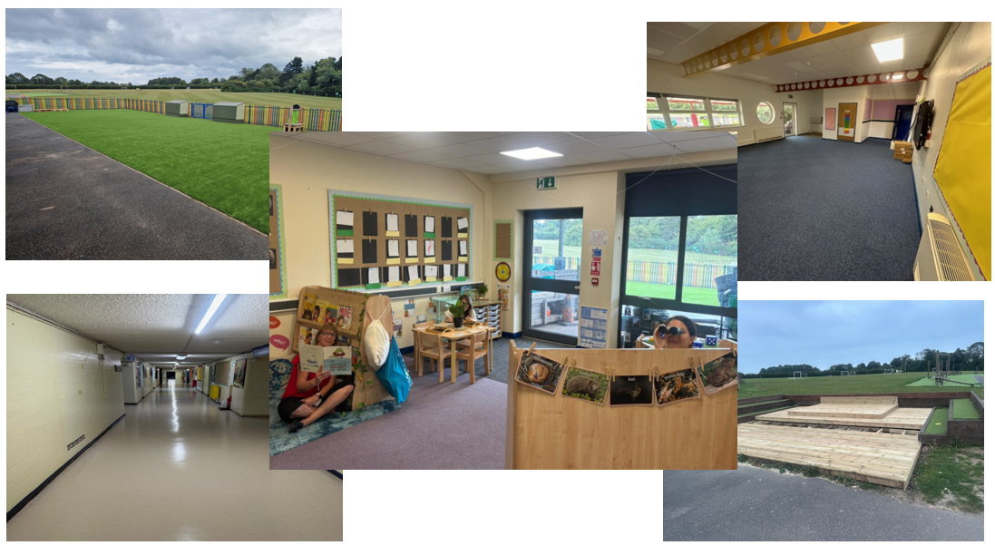
School Uniform
A huge thank you and “hoorah” to all of our families who have supported our school uniform policy so brilliantly. The children look so smart for school and are clearly proud of how they look – as they should be. We think it is the smartest start to a new term – ever!! We know that some parents have had to battle about trousers and shoes and we are so appreciative of your support. Uniform is about ensuring that every child feels like they belong in our school and it is great that you, as parents and families, really support that! Thank you – you are the best!
A Polite Reminder for our children’s safety!
A polite reminder to parents and carers that they should not be entering the school building without a member of staff. Please also ensure that you are not walking around the outside areas other than during pick up and drop off times. This is a safeguarding issue and we have to ensure that all adults on school site are accounted for.
Harvest Festival

On Friday 3rd October, we will be celebrating Harvest Festival in a whole school assembly. To celebrate, we will be getting together as a school to give thanks for all the food we are lucky enough to have. Our assembly will include singing along to our favourite harvest songs, and learning more about where food comes from, as well as learning about the festival of Harvest around the world. To help celebrate, we are inviting children to bring in non-perishable items for donations to the Salvation Army, who provide support to many families in our local area. Donations could include tinned, packet foods, dried foods, jars, pasta and cereals. If you are able to join in and support, we ask that all donations are in school by Wednesday 1st October 2025. Thank you.
What a photograph! – SCHOOL PHOTOGRAPHS
Individual and sibling school photos will take place on Monday 29th September. Any children who are absent on this day will be able to have a catch-up photo on the 2nd October. Please ensure that all children are in school uniform on this day. Any children who have PE on this day, should bring PE kit to change in to.

Newington PE and Sport
It’s been a great start to the term with lots of our pupils super excited to get back to PE. This year we have introduced the REAL PE programme to our subject area to ensure our pupils fundamental skills are fully embedded throughout their year.

It is an important reminder that although the weather is glorious at times still and we as a PE team are appreciating the sun, please be prepared to send your child to school with the correct clothing for the weather.
School PE kit consists of: -
- Black shorts or Black/Navy tracksuit bottoms or Leggings
- School logo PE top
- School fleece or Jumper
- Trainers/plimsoles.
- Waterproof coat (weather depending)

PE Days
Monday: Year 6 (AM)
Tuesday: Year 3 (AM) and Year 1 (PM)
Wednesday: Reception (AM) and Year 5 (PM)
Thursday: Year 2 (AM) and Year 4 (PM) Venus and Cygnus -Swimming and Eclipse and Saturn are PE
Friday : Nursery (PM)
Please ensure pupils with long hair have it tied back for their PE day and no jewellery.
Parents Evening
We are very excited for our parents evening this term where you will get the opportunity to meet your child's new class teacher. You will be able to discuss how they have settled into their new year, celebrate any successes so far and talk about how the year ahead will look. It is a very valuable meeting and it is expected that every child is represented. The dates are:

Wednesday 1st October 2025
Wednesday 8th October 2025.

The booking system will open on Monday 22nd September and close Friday 26th September.
More information regarding parents evening will be sent out shortly.

Well done to Year 6

A huge well done to our Year 6 children who completed their Kent Test this week and to the rest of the cohort who supported them so brilliantly. We are all so proud of their approach to the test (which can be very challenging). They came in, settled their nerves, supported each other and listened to every bit of staff instruction and direction. We couldn’t have asked for more from them and we are so proud of each and every one of them. Well done!

Secondary School Open Days
We are encouraging all Year 6 children to get out and about and access as many of the secondary school open events as possible. These visits can take place during the school day without any issue. Please let the class teacher know if you are planning to take your child to an open day.
Good Luck Miss Berryman
You may well have noticed that our wonderful Miss Berryman is growing a little human and she is doing it wonderfully. Miss Berryman will start her maternity leave very soon and I know that you will all join me in wishing her the very best for the arrival of her new baby. Good luck Miss Berryman, we will miss you and look forward to seeing you when the new baby arrives!
A super busy start to the new school year and it has been truly fabulous to see our children engaging with being back to school; working hard and entering school events. There really has been so much to celebrate. The school is looking amazing and benefitting from some much-needed investment and the children have settled back in to school life brilliantly. It has been an exceptional start to the new year.

Have a great weekend from all of Team Newington! See you next week.

With very best wishes

Hannah Tudor
Headteacher

