
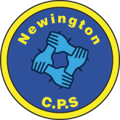
Dds
Newington Community Primary School
Princess Margaret Avenue, Ramsgate, Kent. CT12 6HX
Tel: (01843) 593412 Fax: (01843) 850323
Headteacher: Miss Hannah Tudor
E-mail: headteacher@newington-ramsgate.kent.sch.uk
Ambition, Achievement, Aspiration

Tuesday 2nd September 2025

Dear Parents and Carers
A very warm welcome back to the new school year and a special welcome to any new families joining us. We are very much looking forward to welcoming the children back to school tomorrow and we hope that you have all enjoyed a wonderful summer holiday. This newsletter aims to give you all of the vital information that you will need to ensure that the start of term is as smooth as possible.

Working in Partnership
We aim to work in partnership with all of our families to ensure that every child at Newington gets the best possible school experience. Our teachers are committed to getting to know the families of children in their classes but this can take time. Please be patient as staff get to know your child, build relationships with them and find out their likes and dislikes. Your child is about to go through a “settling in” period that will bring with it some ups and downs. You play a key role in supporting the staff at Newington to get to know your child. If there is something that you feel the classroom adults need to know, speak to them on the door or send a little not on see-saw. It is important that adults work together to ensure that all children settle well in their new classes.

Who should I speak to about…….?
We are a large school and it is important that parents and carers know who to speak to with any concerns or queries they may have. Here is a list of staff you can contact if you need to.
Your child’s progress in class, home learning, friendships, classroom incidents | Contact your child’s class teacher via see-saw or arrange an appointment to speak in person
You are concerned a child has been harmed (safeguarding) | Miss Harrison  Tracey Stillman | r.harrison@newington-ramsgate.kent.sch.uk  t.stillman@newington-ramsgate.kent.sch.uk
Your child cannot attend school | Sarah Ayling | attendance@newington-ramsgate.kent.sch.uk
Your child has an illness or injury that will require treatment in school | Sharon Robb | s.robb@newington-ramsgate.kent.sch.uk
Wraparound provision | Tracey Stillman | t.stillman@newington-ramsgate.kent.sch.uk
Uniform | Speak to staff in the office
On-going behaviour concerns that have not been resolved after talking to the teacher | Miss Harrison  Miss Tudor | r.harrison@newington-ramsgate.kent.sch.uk  headteacher@newington-ramsgate.kent.sch.uk
After School Clubs | Mrs Clements | g.clements@newington-ramsgate.kent.sch.uk
Special Educational Needs and referrals to outside agencies (Greenbanks etc) | Mrs Legge | s.legge@newington-ramsgate.kent.sch.uk
Your child has developed an allergy | Miss Robb | s.robb@newington-ramsgate.kent.sch.uk
Holiday food vouchers and HAF Club | Tracey Stillman | t.stillman@newington-ramsgate.kent.sch.uk
Your child is playing in a school sports event | Mr Moore | r.moore@newington-ramsgate.kent.sch.uk
Admissions to school or nursery/Open events for new parents | Mrs Biggs | c.biggs@newington-ramsgate.kent.sch.uk

HELP! I don’t know where the classroom is!
Don’t worry! There has been extensive work over the summer and year groups have changed classes, making it a little more challenging to remember where the classroom is. A separate letter has gone out to explain a “dropping off” plan for tomorrow morning. You will need to know your child’s class name and then head for the member of staff that you have been given. They will lead you in the right direction. I will be on the gate as usual to welcome all of the children back to school. Staff will also explain collection plans during morning drop off if needed. A reminder of the classes in each year group are below:

Reception | Andromeda, Supernova, Great Bears
Year 1 | Pegasus, Orion, Galaxy
Year 2 | Pluto, Mercury, Gemini
Year 3 | Stardust, Moonbeams, Comets and Cosmos
Year 4 | Saturn, Eclipse, Venus, Cygnus
Year 5 | Neptune, Mars, Earth, Libra
Year 6 | Jupiter, Perseus, Phoenix, Luna

School to Home Communication
I hope that you have all had the opportunity to visit our new school website. We have worked hard to make sure that this is a website that showcases our school but also provides key information for our families. Many dates have now been added to the events calendar for next year. Please have a look so that you can be well informed of what’s coming up at Newington! The events page can be found by clicking on this link.
Newington Community Primary School - Events

A medical update from Miss Robb:

Allergies and Intolerances
If your child has any allergies or food intolerances it is vital that you inform the school. In preparation for the new school year we are updating all information held in school regarding allergies and intolerances.
We are aware that some children can grow out of allergies or develop a new ones, so it is vital that this information is reviewed yearly. A reminder to please complete the Allergy and Intolerance form, sent out via text message and See Saw in order for us to be prepared.
Equally if you think the school could hold allergy or Intolerance information on your child that is no longer relevant, please update us via the allergy form. Thank you!
Asthma
The new Asthma bag and tag system implemented across school last year was successful so will continue this new school year.
If your child needs an Asthma pump in school this term they must be brought to the office where a new Asthma Plan must be completed for their new class. If your child has a personalised Asthma plan, we will use this in school and will take a copy for our records. We will only accept boxed inhalers with an appropriate label attached. The medical officer will then bag and tag for use in class for your child as and when needed. We do hold emergency blue inhalers in school and the Asthma plan gives us permission to administer in the event of need once signed. We do not administer emergency asthma inhalers without permission, a plan or inhaler in school and you will be notified immediately pre-use to keep you informed.
Medicines
Don't forget if your child needs prescribed medicines you must complete an administering medicine form kept in the office. Please do not send in with your child or give teachers the medicines to administer or manage. All medicines are kept in the medical room for safe administration, recording and storage. This also includes creams, eye drops, and any other medications.
Did you know we hold children's paracetamol as well as various children's anti histamines?
Please do not send these in unless prescribed and a form has been completed. We can and will give your child these if they need it especially if you have administered in the morning we will always call and check the reason why and the timing of the last dose and to confirm time of administration.

School Uniform Expectations
A reminder that we expect all children to wear correct school uniform, including school shoes, at all times. Our uniform policy can be found on the school website and uniform is available from the School Wear Shop. Our uniform expectations extend to PE kit and this is also outlined in our policy. Jewellery should not be worn to school with the exception of a watch (no Smart watches please) and a small pair of stud earrings. Children should not wear rings, hooped earrings of necklaces for health and safety reasons and to avoid loss or damage.
Haircuts should be sensible in both style and colour. Children should not come to school with obviously dyed hair in bright colours. Shaved “tram lines” are also not permitted.
We ask that children do not wear false or acrylic nails to school. These can scratch or rip, resulting in injury.
School Shoes – black trainers are no longer a part of our school uniform. All shoes must be completely black and “polishable”
Cycling Shorts – cycling shorts are no longer a part of our school uniform or PE Kit and should not be worn to school.
We look forward to seeing all of our children in smart school uniform in September. We have some pre loved uniform in school. Any families who feel they could benefit from this, please contact a member of the welfare team – Holly, Tracey or Sarah and it can be sorted out ready for September.
A plea that all school uniform is clearly labelled with your child’s name. Labels can be stitched, ironed or your child’s name written on the label with a Sharpie. Please do not send your children to school tomorrow with uniform that is not named. It will be impossible to return missing jumpers, cardigans and fleeces and our poor lost property box will not be able to cope. Thank you!
PE and Sport
We ask that children come to school in full PE kit on their allocated days. PE will start the week beginning 8th September 2025. The school PE timetable looks like this:
PE Day for Term 1 | Year Group
Monday | Year 6
Tuesday | Year 3 and Year 1
Wednesday | Early Years and Year 5
Thursday | Year 2 and Year 4

Consent to Walk Home
We value independence and are always thinking about how we prepare our children for the next step. However, this must always go hand in hand with safety. In line with school policy, with parental consent, Year 5 and 6 will be able to walk to and from school on their own if families wish. We would like to remind all of our families that new consent forms for this will go home in September. No child will be able to walk unaccompanied to and from school without written consent from parents and carers. Thank you!
After School Clubs
Clubs for Terms 1 and 2 will start on Monday 8th September. Breakfast Club and Wraparound will start on Wednesday 3rd September 2025 at the usual time of 7.45am.
Lunch, Snacks and Water Bottles
Lastly, please see this week’s lunch menu.
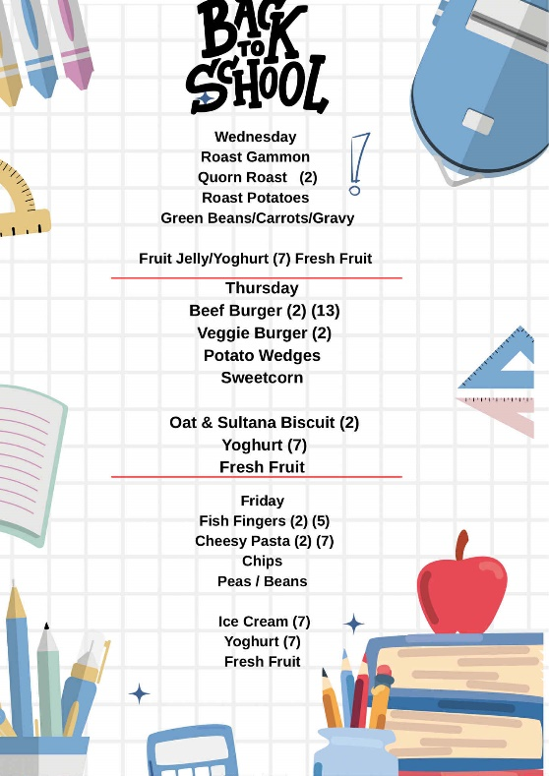
Snacks and Water
Children in Reception and KS 1 do not need to bring a snack to school. Snacks in these year groups are covered by the Fruit and Vegetable Scheme and the school is an active member of this scheme. Children in Years N – 2 are provided with a wide range of fruit and vegetable snacks each day and these are delivered to the classrooms by some of our wonderful Year 6 children.
Children in Years 3 – 6 can bring snacks to school, however the school has a clear policy on snacks and we ask all families to respect this policy. Agreed snacks are: any fruit or vegetable, yoghurt, fruit based snacks (Winders, Fruit Flakes or Raisins), Rice Cakes. Crisps, biscuits and chocolate are not to be brought in to school as snacks.
There is fresh drinking water accessible to all children throughout the school. Children must bring a named water bottle to school each day to ensure that water is available throughout the day.
We are looking forward to a great start to Term 1 – the teachers are ready, the school is looking amazing and we have been eagerly waiting to meet our new Reception starters – what an adventure they will have. I will send another newsletter very soon with some early celebrations to share with you all.

With very best wishes

Hannah Tudor

